November 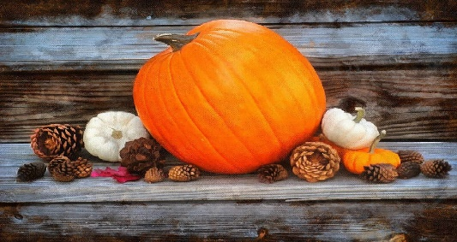 Newsletter

Hello patrons and friends of Chase Library! We have officially begun the countdown to the holidays!! And that’s just fine! For the first time in two years we have the option to hug family and friends for the holidays. That is a very wonderful option! Just thinking about possibly being together is joyous!!

Here are the library updates:

- Our first in-person author event held in October was a happy, sold out, successful event. Another is planned for November:

Join Chase Library and support Below the Brine Bookshop in Harwich Port as Chase presents author Juliette Fay discussing her new book, Catch Us When We Fall.

Gather at the 400 East in Harwich, Wednesday, November 10, from 3-5 pm. Coffee, tea and appetizers will be served; a cash bar will be available.

Reserve your spot: call the library (508-432-2610) or email chaselibrarywh@gmail.com. Tickets are $40.

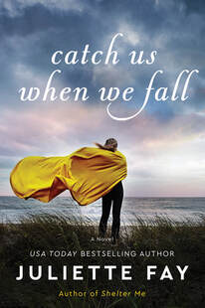

Make your check payable to Chase Library. Drop payment at the library or mail to the library: PO Box 457, West Harwich, 02671. Or you can pay on line via the website: chase-library.com. Click on Support Us at the top of the page, then use the DONATE button to make your payment.

- Thanks to the generosity of library patrons and friends, the repair and re-shingling of the library’s roof has been completed! And none too early given the weather of the last week in October!! You ARE the best!!

- In addition, we salute two of our loyal patrons whose generosity is un-wavering. Their significant contributions enabled us to contract with New England Alarm; hard-wired fire detection and security systems are now in place at the library. Those of us who live in West Harwich no longer hold our breaths waiting for a phone call when we hear sirens on Route 28!

- The library will be open the Saturday after Thanksgiving.

November brings thoughts of Pilgrims and Native Americans. Last year was to have been the 400th anniversary of the landing of the Mayflower in Plymouth. The newly restored vessel travelled to Plymouth in anticipation of many 400th events - ultimately cancelled due to the pandemic. This year, the 400th festivities will take place! There are numerous Plymouth websites listing the many, many celebratory activities for this year. If you have never been, we highly recommend America’s Hometown Thanksgiving Parade, Saturday, Nov 20, at 11 am. If it stays true to past years, the parade kicks of with a contingent of indigenous peoples, followed by pilgrims, and then traces the history of our nation through expansion, triumphs and wars. There are re-enactments, crafts (both historical and current) and of course, food. You can visit Plymouth Rock and tour the Mayflower, a short walking distance away. You should definitely consider a trip to Plymouth Plantation, where volunteers take on the personas of the first settlers!

Chase Library offers several volumes that speak of the lives of Native Americans. Some are fiction, some are non-fiction: Killers of the Flower Moon by David Grann is a non-fiction account of the murders of Osage Indians and the birth of the FBI. I learned so much about this nation’s negative opinions of indigenous people. There, There is current fiction authored by Tommy Orange, a Native American. It has been characterized a shattering portrait of an America few of us have every seen. Chase also has several books by Louise Erdrich, a member of the Turtle Mountain Band of Chippewa Indians. Erdrich is viewed as one of the most significant current writers of Native American stories. She has written 28 books in all, including fiction, non-fiction, poetry, and children's books. Each of these volumes contains revelations of our nation’s treatment of Native Americans. And if you wish to read about pilgrims, you could choose Mayflower by Nathaniel Philbrick. Or try Beheld by TaraShea Nesbit. It is a historical fiction novel that begins with the accidental (??) death of Gov. William Bradford’s first wife, then moves to Plymouth colony and becomes the story of women told by women. And yet….as noted in the New York Times’ review: “On the one hand, the English pilgrims regard themselves as epitomizing civility, manners and thus superiority. On the other hand, they deploy barbaric cruelty in order to defend that superiority. For all the novel’s quietness of telling, its currency is the human capacity for cruelty and subjugation, of pretty much everyone by pretty much everyone.” It was quite the read!

That’s all for now, folks. All of us at Chase Library wish you a good month, a meaningful holiday, and lots of good reading!!

